**EXCEL ASSIGNMENT - 10**

**1. See the below picture and create the exact table with exact formatting.**

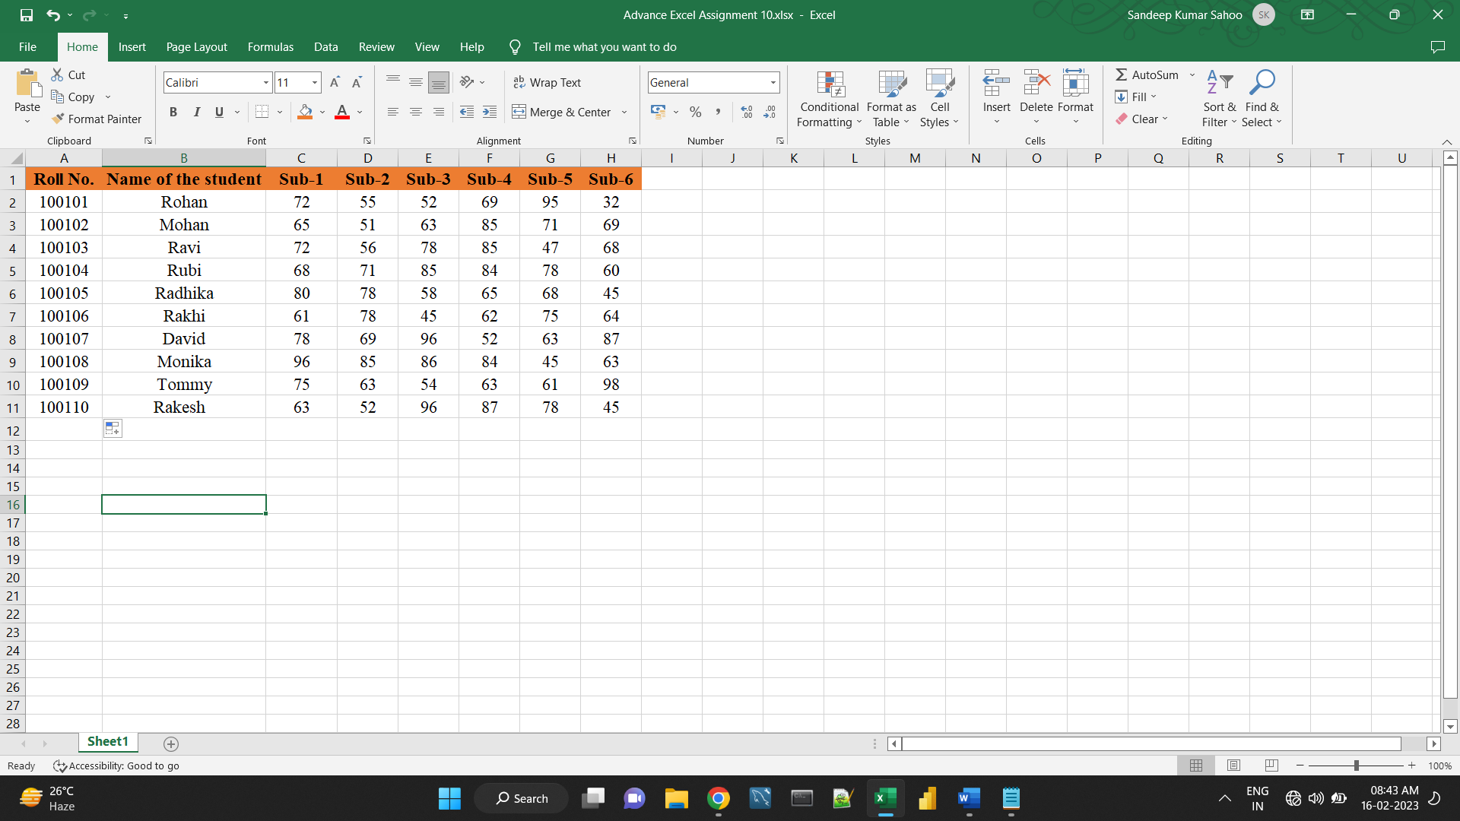**Font – ‘Times New Roman’ Size – 14, Colour of first line Orange.**

**2. From the above table use Sum Formula and find the total for each student.**

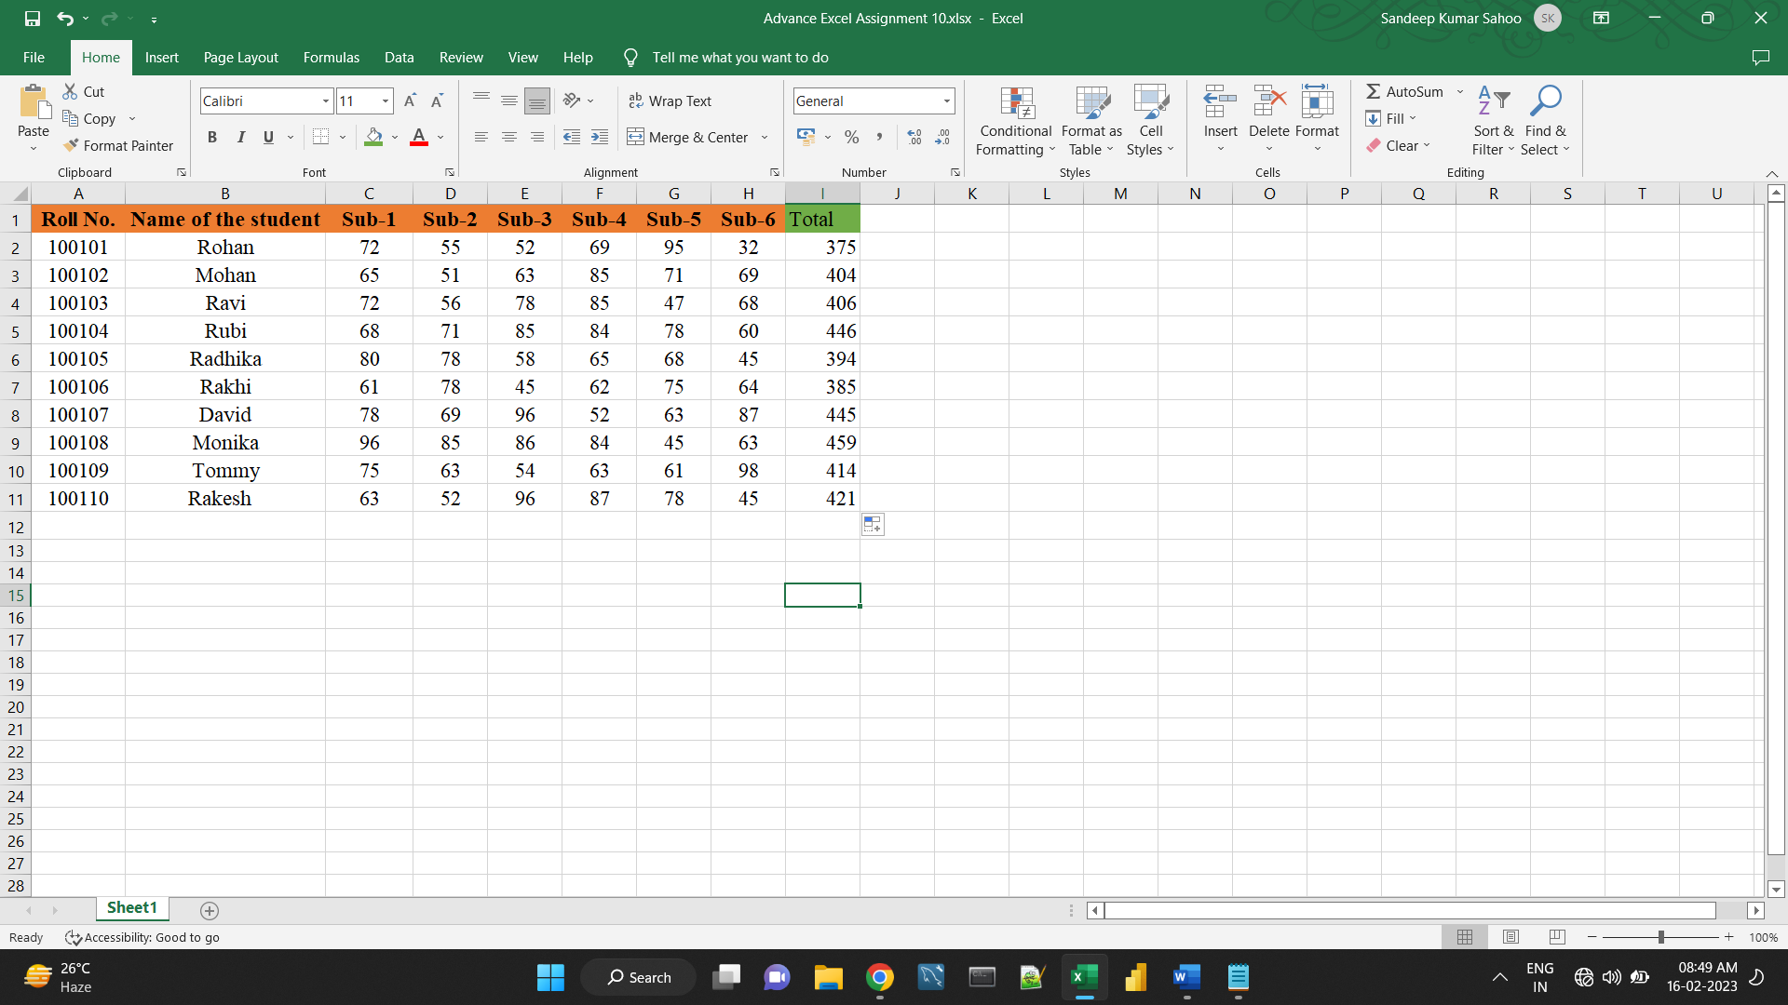

**3. Calculate Average for each student in the next row. Use Formulas.**

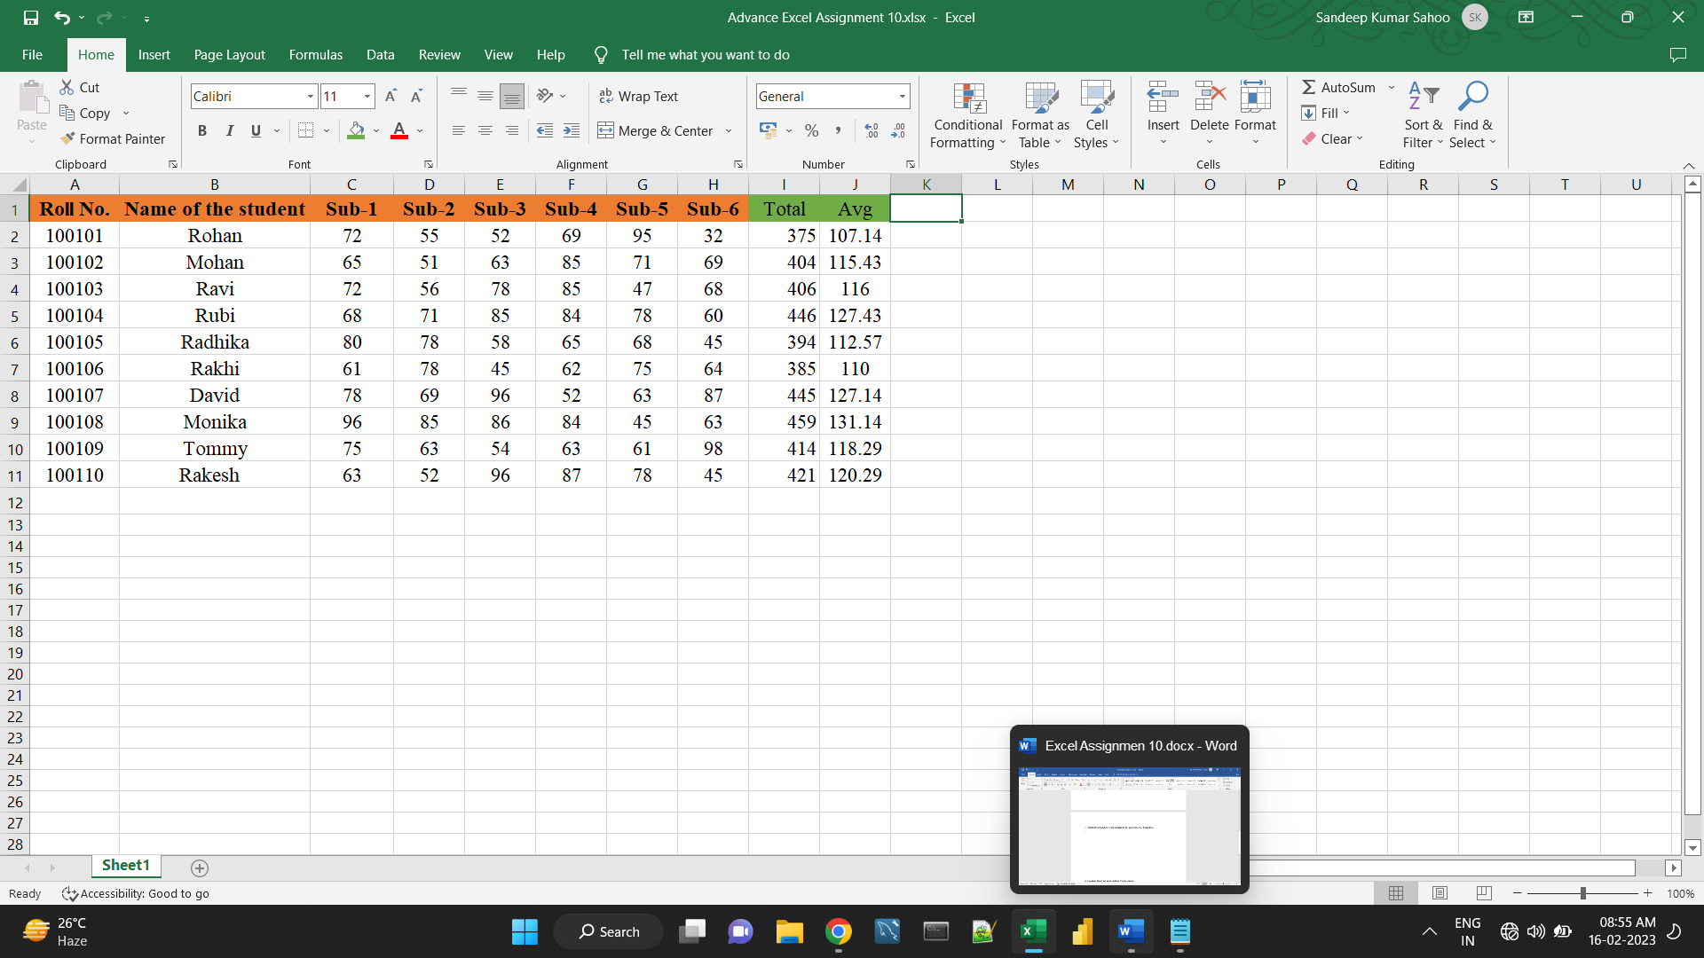

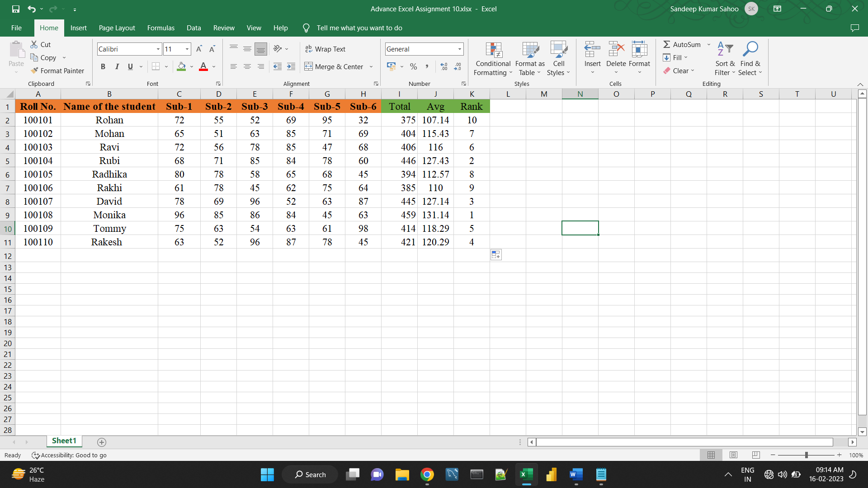**4. Calculate Rank for each student. Use Formulas.**

**5. Calculate Percentage for each student. Use Formulas. Round off the decimals up to 2 points.**

